CLOUD COMPUTING PROJECT REPORT
GitHub • Jenkins • Terraform • Docker • Docker Swarm • AWS EC2

Student Name: [Enter your full name]
Course: [Enter course name / section]
Project Title: Portfolio Application — Cloud Deployment
Submission Date: [Enter submission date]
GitHub Repository: https://github.com/natvannak/portfolio

1. Introduction
This project demonstrates a cloud deployment workflow for a portfolio application. It combines GitHub version control, Jenkins automation, Docker image packaging, Docker Swarm orchestration, Terraform infrastructure tracking, and AWS EC2 compute resources. The application is exposed through an Nginx load-balancing entry point and runs as containerized services on a three-node Swarm cluster.
The objective is to demonstrate reproducible infrastructure configuration, automated build and test steps, container image publishing, multi-node orchestration, and operational verification against the course rubric.

2. System Architecture
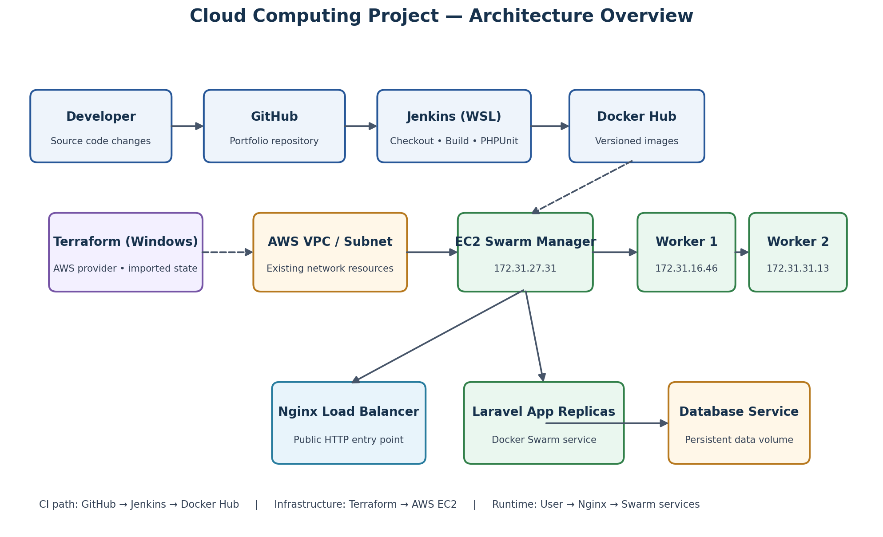
CI path: developer changes are pushed to GitHub; Jenkins checks out the source, builds the application, runs automated tests, and publishes versioned images to Docker Hub. Infrastructure path: Terraform uses the AWS provider and tracks the existing VPC, subnet, security group, and three EC2 instances. Runtime path: visitors send HTTP requests to Nginx, which routes traffic to the application services managed by Docker Swarm.

3. Technology Implementation

3.1 GitHub
The project source is maintained in GitHub at https://github.com/natvannak/portfolio. The Terraform configuration was committed and pushed in commit 4def0c6 with the message 'Add Terraform AWS infrastructure configuration'. The repository .gitignore excludes environment files, dependency folders, Terraform working directories, state files, state backups, and plan files while retaining the Terraform provider lock file.

3.2 Jenkins CI Pipeline
Jenkins runs in WSL. The recorded pipeline performs source checkout, workspace preparation, validation, container build, Composer/Laravel setup, PHPUnit tests, versioned image creation, Docker Hub login, and image push. A successful run (Build #8 in the project history) completed the build, PHPUnit, and push stages.
Status qualification: the available project history confirms CI build/test/image publishing. It does not confirm that Jenkins automatically deploys to AWS Swarm or that a GitHub webhook/SCM polling trigger is enabled. Those rubric items must be tested and documented separately.

3.3 Terraform Infrastructure as Code
Terraform v1.17.1 for windows_amd64 and AWS provider v6.71.0 are used. The project contains provider, version, data-source, EC2, security-group, and output configuration files. Existing AWS resources were imported into Terraform state. The verified state list includes the VPC, subnet, security group, manager, and two worker data sources, plus managed-state addresses for the three EC2 instances and security group.
The most recent terraform plan returned: 'No changes. Your infrastructure matches the configuration.' This verifies alignment between the current Terraform configuration and imported state. It should not be presented as proof that Terraform originally created the AWS infrastructure. The current state is local and ignored by Git; no remote backend has yet been confirmed.

3.4 Docker
Docker is used to package the application and supporting services into images. The Jenkins pipeline builds versioned images and pushes them to Docker Hub. The project also uses a Compose configuration for local/build workflow; confirm the exact compose filename and services in the repository before final submission.

3.5 Docker Swarm
The deployed cluster consists of one manager and two worker EC2 instances. The portfolio stack includes application replicas, an Nginx load-balancing service, and a database service with persistent storage. Collect current docker node ls, docker stack services, and docker stack ps output as final evidence. Do not remove or recreate the database volume while gathering evidence.

3.6 AWS EC2
The recorded AWS region is us-east-1. The cluster consists of three t3.micro EC2 instances: one manager and two workers. The instances use a shared project security group and SSH key-pair access. Verify the final security-group rules in the AWS console: public HTTP/HTTPS as required, SSH restricted to a trusted source, and Swarm ports restricted to communication between cluster nodes.

4. Testing and Verification
The following checks have been recorded or should be captured as final submission evidence:
Test | Evidence / status
Terraform formatting and validation | Run terraform fmt and terraform validate; attach terminal screenshot.
Terraform plan | Verified result: No changes. Your infrastructure matches the configuration.
Terraform state | Verified state contains data sources for VPC/subnet/EC2/SG and managed addresses for three EC2 instances and the SG.
Jenkins pipeline | Attach successful Jenkins build screenshot showing checkout, build, PHPUnit, Docker image build, and push.
Docker registry | Attach Docker Hub repository/tag screenshot.
Swarm cluster | Capture docker node ls showing manager and two Ready workers.
Swarm services | Capture docker stack services portfolio and docker stack ps portfolio.
HTTP availability | Run an HTTP request against the current public endpoint and record actual status and response.
Rolling update / failover | Only claim success if tested; attach before/after replica and request evidence.

5. Challenges and Solutions
- Terraform planned unwanted instance changes: The EC2 resource configuration did not contain all imported instance resource blocks. Restoring the manager and both worker blocks brought configuration back into alignment; the next plan reported no changes.
- Terraform state files appeared as untracked files: The root .gitignore was updated to ignore .terraform directories, *.tfstate, state backups, and plan files. The provider lock file remains tracked.
- Windows line-ending notice: Git displayed an LF-to-CRLF warning for .terraform.lock.hcl. This was a line-ending notice; the commit and push completed successfully.
- Jenkins workspace permission issue: Workspace ownership and permissions were corrected for the Jenkins service user so pipeline operations could access generated files.

6. Conclusion
The project has brought together source control, a Jenkins CI workflow, Docker image publishing, Terraform tracking of AWS resources, and a multi-node Docker Swarm deployment. The work demonstrates how application delivery and cloud infrastructure components fit together. The remaining work is to capture final runtime evidence, complete the README and report with actual screenshots, and verify rubric items that are not yet confirmed, especially automatic Jenkins deployment, SCM triggering, full Terraform provisioning coverage, and rolling-update/failover evidence.

7. References
- Cloud Computing Project Rubric, course handout supplied for this assignment.
- HashiCorp Terraform Documentation — https://developer.hashicorp.com/terraform/docs
- Docker Documentation — https://docs.docker.com/
- Docker Swarm Documentation — https://docs.docker.com/engine/swarm/
- Jenkins User Documentation — https://www.jenkins.io/doc/
- AWS EC2 User Guide — https://docs.aws.amazon.com/AWSEC2/latest/UserGuide/concepts.html
- GitHub Documentation — https://docs.github.com/
- OpenAI ChatGPT — assistance with project documentation drafting and organization (disclose per course academic-integrity rules).

Appendix A — Screenshot Checklist
- GitHub repository root showing README, Jenkinsfile, Docker/Compose files, Terraform folder, and Swarm manifest.
- GitHub commit history and feature branch / pull request evidence.
- Jenkins successful pipeline stages and PHPUnit result.
- Docker Hub repository showing pushed image tags.
- Terraform terraform validate and terraform plan output.
- AWS EC2 console showing manager and two workers with tags.
- AWS security group inbound rules.
- Docker Swarm docker node ls output.
- Docker stack services and docker stack ps output.
- Browser or curl/Invoke-WebRequest showing live application response.
- Rolling update or failover test evidence, if performed.
Before submission: replace bracketed cover-page fields, correct any repository filenames that differ from the actual project, insert real screenshots, and remove any statement that cannot be supported by test evidence.

